A PROJECT REPORT ON

# “Maharashtra Virtual Tourism Application”

SUBMITTED IN PARTIAL FULFILLMENT OF THE REQUIREMENTS FOR

THE AWARD OF

**DIPLOMA IN**

COMPUTER TECHNOLOGY



SUBMITTED TO MAHARASHTRA STATE BOARD OF TECHNICAL EDUCATION, MUMBAI

SUBMITTED BY

|  |  |  |
| --- | --- | --- |
| Sr.No | Student Name | Enrollment No. |
| 1 | Dattatray Jaysingrao Bhagnagare | 2000940085 |
| 2 | Atul Madhavappa Hese | 2100940155 |
| 3 | Govind Sakharam Mane | 2100940168 |

GUIDED BY

(Prof. P.B. Kale Sir)



**Government Polytechnic Jintur 2022-23**

# CERTIFICATE

This is to certify that the project report entitled **“Maharashtra Virtual Tourism Application”** Was Successfully completed by Student of sixth semester Diploma in (Computer Technology).

1. Dattatray Bhaganagare (2000940085)
2. Atul Hese (2100940155)
3. Govind Mane (1909930063)

in partial fulfillment of the requirements for the award of the Diploma in (Computer Technology) and submitted to the Department of (Computer Technology) of Government Polytechnic, Jintur work carried out during a period for the academic year 2022-23 as per curriculum.

Name of Guide Name of HOD

(Prof. P.B. Kale) (Prof. A.K. Rathod)

External Examiner Principal

## Sponsorship Letter

Date / /2023 TO,

1. Dattatray Jaysingrao Bhaganagare
2. Atul Madhavappa Hese
3. Govind Sakharam Man

**Ref: - Letter NO \_\_\_\_\_\_\_\_\_\_\_\_\_\_\_\_\_\_ regarding Sponsorship Dated on / /**

### Subject: - Sponsorship for project,

There is always scope for technical advancement. Many Organizations, industries like ours working hard to develop our business with the help of recent technologies, Application Software.

The project entitled **“Maharashtra Virtual Tourism”** is technologically advance and is user friendly, App/Website and it is beneficial for us.

So, we are glad to sponsor this project to encourage the students in their learning phase and to promote earn and learn scheme. WE will to provide financial support to this Project.

Sincere thanks,

**From: \_\_\_\_\_\_\_\_\_\_\_\_\_\_\_\_\_\_\_\_\_\_\_\_\_\_\_\_\_\_\_\_\_\_\_\_\_\_\_\_\_\_\_\_\_\_\_\_\_\_**

**Date and Address: \_\_\_\_\_\_\_\_\_\_\_\_\_\_\_\_\_\_\_\_\_\_\_\_\_\_\_\_\_\_\_\_\_\_\_\_\_\_\_**

**Contact if Needed: \_\_\_\_\_\_\_\_\_\_\_\_\_\_\_\_\_\_\_\_\_\_\_\_\_\_\_\_\_\_\_\_\_\_\_\_\_\_\_\_**

# ACKNOWLEDGMENT

This project is done as a semester project, as a part of course titled **“Maharashtra Virtual Tourism Application”** We are really thankful to our course, the Principal (**Prof. L. N. Raut**) and the HOD (**Prof. A. K. Rathod**), Computer Technology, Government Polytechnic, Parabhani for their invaluable guidance and assistance, without which the accomplishment of the task would have never been possible. We also thank **Prof. A.K. Rathod** for giving us this opportunity to explore into the real world and realize the interrelation without which a Project can never progress. In our present project we have chosen the topic- **“Maharashtra Virtual Tourism Application”**. We are also thankful to parents, friend and all staff of Computer Technology department, for providing us relevant information and necessary clarifications, and great support. Always grateful.

**Table Of Contents**

**LIST OF FIGURES …………………………………………………8**

**ABSTRACT …….……………………………………………………9**

**CHAPTER ONE ….………………………………………………….11**

## INTRODUCTION …....………….….……………………………….11

1.1 PROJECT INTRODUCTION ……...…………………........11

1.2 OBJECTIVES ……...…………….….…….….………........12

1.3 PROPOSED SYSTEM ……...…………….….………........13

1.4 PROJECT OVERVIEW ……...……………………….........14

1.5 PROJECT SCOPE …….……...……………………….........15

**CHAPTER TWO ...…………………………………………………17**

## LITERATURE REVIEW………………...………………………...17

2.1 LITERATURE REVIEW ...………………….……………**17**

2.1 STATUS OF ONLINE TOURISM ..……………………...**18**

2.1 PROBLEMS OF ONLINE TOURISM ..…….…………....**19**

2.1 THE FACTORS WHICH AFFECTS.…………………….20

## CHAPTER THREE………………………………….……………...21 REQUIREMENT ANALISYS…………...………………………...21

3.1 SYSTEM REQUIREMENTS………...………..………….….21

3.2.1. HARDWARE REQUIREMENTS.............………………...........................21

3.2.2. SOFTWARE REQUIREMENTS ...........………………..............................21

**CHAPTER FOUR ...…………………….………………………….22**

## METHODOLOGY ...……………………...…………………….….22

4.1 INTRODUCTION ……...………………….….……….….....23

4.2 FESIBILITY STUDY ……….……...………....…………......23

4.3 SYSTEM ANALYSIS ……………………….....…………....24

4.4 REQUIREMENT ANALYSIS AND SPECIFICATION…….24

**CHAPTER FIVE ......……………………………………………….25**

## DETAIL DESIGN ...…………………………………………….….25

5.1 INTRODUCTION ……...………………….….……….…......**25**

5.2 APP/WEB SNAPS.………….……...………...……………….**26**

**CHAPTER SIX …...………………………………………………...28**

## EXPERIMENTAL STUDY……. ...………………………………..28

6.1 HYPER TEXT MARKUP LANGUAGE…..………….….... **.28**  6.2 CASCADING STYLE SHEET……...…....…….……..……..29

vii

6.2 JAVASCRIPT……...…....……………………………………33 **CHAPTER SEVEN.………………………………………………,,,43**

## IMPLEMENTATION DETAILS …..……………………………..45

7.1 INTRODUCTION…...……………………..……….…...........46

7.2 OVERALL DESCRIPTION………………..……….…........**..46**

7.1 SYSTEM REQUIREMENTS….…………..……….…...........47

## CONCLUSION AND SCOPE FOR FURTHER STUDIES ….….47

7.1 CONCLUSION ……...……………………..……….…..........48

7.2 FUTURE SCOPE…….. ..…….……...………....………….....48

**REFERENCE ...…...………………………………………………..49**

viii

# LIST OF FIGURES

|  |  |  |
| --- | --- | --- |
| **Sr. No** | **Name Of Figure** | **Page No.** |
| 1 | Splashscreen Image | 26 |
| 2 | Homepage Screen Image | 26 |
| 3 | List of Places/Navigation | 27 |
| 4 | About Box | 27 |
| 5 | Streetview screen | 27 |
| 6 | Place description | 27 |

**Abstract**

The Maharashtra Virtual Tourism Application is a project aimed at promoting tourism in the state of Maharashtra, India through the use of technology. The application provides a virtual platform for tourists to explore various destinations in Maharashtra from the comfort of their own homes. This project report highlights the development process of the application, including the design, programming, and testing phases. It also discusses the challenges faced during the development process and the solutions implemented to overcome them. The report includes a detailed analysis of the application's features and functionalities, as well as the user interface and user experience design. The project's impact on promoting tourism in Maharashtra is also evaluated, including the number of downloads and user feedback. The report concludes with recommendations for future enhancements to the application and its potential for further growth and expansion. Additionally, the project report highlights the technology stack used for developing the Maharashtra Virtual Tourism Application, which includes various programming languages, frameworks, and libraries. The report also covers the project's deployment and hosting process, including the infrastructure and platforms used for deployment.

The Maharashtra Virtual Tourism Application is expected to attract a large number of tourists to the state, particularly those who may not be able to physically visit the state. Through the virtual platform, tourists can explore Maharashtra's rich culture, history, and natural beauty. The application features 360-degree virtual tours, images, videos, and audio guides, making it a comprehensive and immersive experience for users.

In conclusion, the Maharashtra Virtual Tourism Application is a groundbreaking project that utilizes technology to promote tourism in the state of Maharashtra. This project report provides a comprehensive overview of the application's development process, features, and functionalities, as well as its potential impact on tourism in the state. With its user-friendly interface and immersive content, the Maharashtra Virtual Tourism Application has the potential to revolutionize the tourism industry in Maharashtra and beyond.

CHAPTER ONE

# INSTRODUCTION

## 1.1 PROJECT INTRODUCTION

The Maharashtra Virtual Tourism Application is an innovative project aimed at promoting tourism in the state of Maharashtra, India, through the use of technology. Maharashtra is a state with a rich cultural and historical heritage, home to popular tourist destinations such as Mumbai, Pune, Nashik, and Aurangabad. However, due to various constraints such as time, distance, and budget, not everyone can visit these places physically. This is where the Maharashtra Virtual Tourism Application comes in, providing a virtual platform for tourists to explore Maharashtra's tourist destinations from the comfort of their own homes.

The application features 360-degree virtual tours, images, videos, and audio guides, providing users with an immersive experience of Maharashtra's culture, history, and natural beauty. The Maharashtra Virtual Tourism Application is designed to attract tourists from all over the world and provide them with an opportunity to explore Maharashtra's tourist destinations at their convenience.

The Maharashtra Virtual Tourism Application project aims to develop a user-friendly and interactive application that is accessible on multiple platforms such as Android, iOS, and web. The application's primary goal is to promote tourism in Maharashtra, and it is expected to have a significant impact on the tourism industry in the state. The project aims to provide users with a seamless and comprehensive virtual tour of Maharashtra's tourist destinations, enabling them to plan their trips efficiently and effectively.

The Maharashtra Virtual Tourism Application project involves a team of developers, designers, and project managers who will work together to create a robust and reliable application. The project's success depends on the team's ability to design and develop an application that meets the needs and expectations of tourists while also addressing the challenges faced in promoting tourism in Maharashtra. Overall, the Maharashtra Virtual Tourism Application project has the potential to revolutionize the tourism industry in Maharashtra, making it accessible to everyone, irrespective of time, distance, and budget constraints.

## 1.2 OBJEVTIVES

The Maharashtra Virtual Tourism Application project has the following objectives:

**1.**To develop a user-friendly and interactive virtual tourism application that provides tourists with an immersive experience of Maharashtra's culture, history, and natural beauty.

**2.**To provide users with a comprehensive virtual tour of Maharashtra's tourist destinations, including popular destinations and offbeat places.

**3.**To promote tourism in Maharashtra by increasing awareness of the state's tourist attractions and making them accessible to tourists worldwide.

**4.**To enable tourists to plan their trips effectively by providing them with relevant information about the tourist destinations, such as accommodation, transportation, and local cuisine.

**5.**To create an application that is accessible on multiple platforms such as Android, iOS, and web, making it easy for tourists to access the virtual tour from their preferred devices.

**6.**To design and develop an application that is reliable, robust, and scalable, ensuring that it can handle a large number of users and data without compromising on performance.

**7.**To obtain feedback from users and use it to improve the application continually, ensuring that it meets the needs and expectations of tourists.

**8.**To contribute to the growth and development of the tourism industry in Maharashtra, by leveraging technology to make tourism accessible and enjoyable for everyone.

**9.**Overall, the objectives of the Maharashtra Virtual Tourism Application project are to provide a virtual tourism experience that is immersive, comprehensive, and accessible to everyone, while also promoting tourism in Maharashtra and contributing to the state's economic growth.

## 1.3 PROPOSED SYSTEM

The proposed system for the Maharashtra Virtual Tourism Application project is a user-friendly and interactive virtual tourism application that provides users with an immersive experience of Maharashtra's tourist destinations. The application will feature 360-degree virtual tours, images, videos, and audio guides, providing users with a comprehensive virtual tour of Maharashtra's tourist attractions.

The application will be accessible on multiple platforms such as Android, iOS, and web, making it easy for users to access the virtual tour from their preferred devices. The application's user interface will be designed to be intuitive and easy to navigate, enabling users to explore Maharashtra's tourist destinations seamlessly.

The proposed system will also provide users with relevant information about the tourist destinations, such as accommodation, transportation, and local cuisine, enabling them to plan their trips effectively. The application will feature a search function that allows users to search for tourist destinations based on their preferences, such as location, type of destination, and activities.

The proposed system will be designed and developed using modern programming languages, frameworks, and libraries, ensuring that it is reliable, robust, and scalable. The application will be deployed on a cloud-based platform, enabling it to handle a large number of users and data without compromising on performance.

To ensure that the proposed system meets the needs and expectations of tourists, user feedback will be obtained and used to improve the application continually. The application will be regularly updated with new tourist destinations and features, ensuring that it remains relevant and up-to-date.

Overall, the proposed system for the Maharashtra Virtual Tourism Application project is designed to provide users with a seamless, immersive, and comprehensive virtual tourism experience of Maharashtra's culture, history, and natural beauty, promoting tourism in Maharashtra and contributing to the state's economic growth.

## 1.4 PROJECT OVERVIEW

The Maharashtra Virtual Tourism Application project is an innovative and ambitious initiative aimed at promoting tourism in the state of Maharashtra, India, through the use of technology. The project aims to develop a user-friendly and interactive virtual tourism application that provides tourists with an immersive experience of Maharashtra's culture, history, and natural beauty.

The application will feature 360-degree virtual tours, images, videos, and audio guides, providing users with a comprehensive virtual tour of Maharashtra's tourist attractions. The application will be accessible on multiple platforms such as Android, iOS, and web, making it easy for users to access the virtual tour from their preferred devices

The Maharashtra Virtual Tourism Application project has several objectives, including promoting tourism in Maharashtra by increasing awareness of the state's tourist attractions, enabling tourists to plan their trips effectively, and contributing to the growth and development of the tourism industry in Maharashtra

The proposed system for the Maharashtra Virtual Tourism Application project will be designed and developed using modern programming languages, frameworks, and libraries, ensuring that it is reliable, robust, and scalable. The application will be deployed on a cloud-based platform, enabling it to handle a large number of users and data without compromising on performance. To ensure that the proposed system meets the needs and expectations of tourists, user feedback will be obtained and used to improve the application continually. The application will be regularly updated with new tourist destinations and features, ensuring that it remains relevant and up-to-date.

## 1.5 PROJECT SCOPE

The scope of the Maharashtra Virtual Tourism Application project encompasses the development of a user-friendly and interactive virtual tourism application that provides tourists with an immersive experience of Maharashtra's culture, history, and natural beauty. The application will feature 360-degree virtual tours, images, videos, and audio guides, providing users with a comprehensive virtual tour of Maharashtra's tourist destinations

**The project scope includes the following:**

- Design and development of a user-friendly and interactive virtual tourism application that provides an immersive experience of Maharashtra's tourist destinations.

- Inclusion of relevant information about tourist destinations such as accommodation, transportation, and local cuisine, enabling users to plan their trips effectively.

- Development of a search function that allows users to search for tourist destinations based on their preferences, such as location, type of destination, and activities.

- Deployment of the application on multiple platforms such as Android, iOS, and web, making it accessible to users on their preferred devices.

- Regular updates of the application with new tourist destinations and features, ensuring that it remains relevant and up-to-date.

- Obtaining feedback from users and using it to improve the application continually, ensuring that it meets the needs and expectations of tourists.

- Designing and developing the application using modern programming languages, frameworks, and libraries, ensuring that it is reliable, robust, and scalable.

- Deployment of the application on a cloud-based platform, enabling it to handle a large number of users and data without compromising on performance.

The project scope does not include physical infrastructure development or maintenance, such as building new tourist destinations, constructing roads, or providing other physical amenities. It is solely focused on the development of a virtual tourism application to promote Maharashtra's existing tourist destinations.

CHAPTER TWO

# LITERATURE REVIEW

## 2.1 INTRODUCTION

Literature review is an expressive study based on the detailed review of earlier pertinent studies related to the various concepts of online shopping to discover the concept of online shopping. It highlights the status of online shopping, importance and problems of online shopping, factors affecting online shopping and a critical review of the privacy and security issues in online shopping

During the global 2020 COVID-19 outbreak, the advantages of online food delivery (FD) were obvious, as it facilitated consumer access to prepared meals and enabled food providers to keep operating. However, online FD is not without its critics, with reports of consumer and restaurant boycotts. It is, therefore, time to take stock and consider the broader impacts of online FD, and what they mean for the stakeholders involved. Using the three pillars of sustainability as a lens through which to consider the impacts, this review presents the most up-to-date research in this field, revealing a raft of positive and negative impacts. From an economic standpoint, while online FD provides job and sale opportunities, it has been criticized for the high commission it charges restaurants and questionable working conditions for delivery people.

From a social perspective, online FD affects the relationship between consumers and their food, as well as influencing public health outcomes and traffic systems. Environmental impacts include the significant generation of waste and its high carbon footprints. Moving forward, stakeholders must consider how best to mitigate the negative and promote the positive impacts of online FD to ensure that it is sustainable in every sense.

## 2.2 STATUS OF ONLINE TOURISM IN PERSENT BUSINESS ENVIOURNMENT

The Maharashtra Virtual Tourism Application is a user-friendly and interactive virtual tourism application that provides an immersive experience of Maharashtra's culture, history, and natural beauty. The application features 360-degree virtual tours, images, videos, and audio guides, providing users with a comprehensive virtual tour of Maharashtra's tourist destinations.

The Maharashtra Virtual Tourism Application has several advantages over traditional tourism. Firstly, it is accessible to everyone, irrespective of time, distance, and budget constraints. Tourists can explore Maharashtra's tourist destinations from the comfort of their homes or offices, without the need for travel or accommodation expenses. This makes tourism accessible to a wider audience and promotes tourism in Maharashtra.

Secondly, the Maharashtra Virtual Tourism Application is an excellent planning tool for tourists. The application includes relevant information about tourist destinations such as accommodation, transportation, and local cuisine, enabling users to plan their trips effectively. The search function allows users to search for tourist destinations based on their preferences, such as location, type of destination, and activities.

Thirdly, the Maharashtra Virtual Tourism Application provides an immersive experience of Maharashtra's culture, history, and natural beauty. The 360-degree virtual tours, images, videos, and audio guides provide users with a comprehensive virtual tour of Maharashtra's tourist destinations, enabling them to experience the state's rich cultural heritage and natural beauty.

Overall, the Maharashtra Virtual Tourism Application is an innovative and ambitious initiative aimed at promoting tourism in Maharashtra through the use of technology. The application leverages technology to provide a virtual tourism experience that is immersive, comprehensive, and accessible to everyone, while also contributing to the growth and development of the tourism industry in Maharashtra.

## 2.3 PROBLEMS OF ONLINE TOURISM

Online tourism, like any other industry, is not without its challenges. Some of the common problems of online tourism are:

Limited physical experience: Virtual tours, images, and videos provide a glimpse of tourist destinations, but they cannot replace the physical experience of visiting a place. This limitation of online tourism may deter some tourists who value the physical experience of travel.

Lack of personal touch: Online tourism lacks the personal touch that is present in traditional tourism. Tourists may miss the opportunity to interact with locals and experience their culture and traditions.

Security concerns: Online tourism involves the sharing of personal information and financial transactions, which may pose a security risk to tourists. Tourists may be hesitant to share their personal information or make online payments, which could limit the growth of online tourism

Technical issues: Online tourism requires reliable internet connectivity and access to compatible devices. Technical issues such as slow internet speeds, device incompatibility, or software bugs may hinder the user experience and frustrate tourists Language barriers: Online tourism may face language barriers, especially for international tourists. If the application or website is available only in a limited number of languages, tourists who do not understand the language may not be able to use it effectively

Limited scope: Online tourism may not cover all tourist destinations or provide a comprehensive virtual tour of a place. Some destinations may be excluded due to technological limitations or lack of data, which may limit the scope of online tourism.

Overall, online tourism has several challenges that need to be addressed for it to grow and become a viable alternative to traditional tourism. The industry needs to overcome these challenges by providing innovative solutions and leveraging technology to enhance the user experience and meet the needs of tourists.

## 2.4 THE FACTORS WHICH AFFECT ONLINE TOURISM

There are some factors which affect the online tourism by the Kotler who is a great marketing writer.

1. Convenience (no traffic, crowds,24 hr. access )
2. Place Popularity
3. Network

CHAPTER THREE

**REQUIREMENT ANALYSIS**

## 3.1 SYSTEM REQUIREMENTS

**3.1.1 HARDWARE REQUIREMENTS:**

1.PC, Laptop, Mobile Devices

\2. Atleast 2GB Ram

3.Good display/Monitor

4.Stable Internet Wifi or Router

**3.1.2 SOFTWARE REQUIREMENTS:**

1. Visual Studio Code Editor
2. Microsoft Edge
3. Chrome Browser
4. Yarn Package Manager
5. Android Studio
6. MS Word

CHAPTER FOUR

**METHODOLOGY**

## 4.1 INTRODUCTION

This Section describes the methodology applied during the development of this project. A methodology is a model, which project managers employ for the design, planning, implementation and achievement of their project objectives. Effective project management is essential in absolutely any organization, regardless of the nature of the business and the scale of the organization. From choosing a project to right through to the end, it is important that the project is carefully and closely managed. Based on the nature of my project solution, it was essential to use incremental Software development life cycle (SDLC). The project typically has a number of Phases and the level of control required over each phase are primarily defined by the nature of the Project, the complexity of the same and the industry to which the Project has to cater to. An Incremental (SDLC) model consists of a number of dependent increments that are completed in a prescribed sequence. Each increment includes a Launching, Monitoring and Controlling, and Closing Process Group for the functions and features in that increment only. Each increment integrates additional parts of the solution until the final increment, where the remaining parts of the solution are integrated.

## 4.2 FEASIBILITY STUDY

Feasibility study of the system is a very important stage during system design. Feasibility study is a test of a system proposal according to its workability impact on the organization, ability to meet user needs, and effective use of resources. There are five types of feasibility as mentioned below:

1. Technical Feasibility
2. Time Schedule feasibility
3. Operational feasibility
4. Implementation feasibility

## 4.3 SYSTEM ANALYSIS

Analysis is an important part of any project; is analysis is not done properly then whole project move in the wrong direction. It also provides a schedule for proper project work. Analysis task divided into 3 areas

1. Problem Recognition.
2. II. Feasibility Study.

III. Requirement Analysis

## 4.4 REQUIREMENT ANALYSIS AND SPECIFICATION

Requirement analysis and specification is a critical step in the development of the Maharashtra Virtual Tourism Application. This step involves defining the application's functional and non-functional requirements and documenting them in detail. The following are the requirements analysis and specification for the Maharashtra Virtual Tourism Application:

Functional Requirements:

The functional requirements describe what the Maharashtra Virtual Tourism Application should do. The functional requirements for the application include:

a. Virtual Tours: The application should provide 360-degree virtual tours of tourist destinations in Maharashtra, enabling users to explore the destination in detail.

b. Multimedia Content: The application should include multimedia content such as images, videos, and audio guides that provide additional information about the tourist destination.

c. Search Function: The application should have a search function that enables users to search for tourist destinations based on their preferences, such as location, type of destination, and activities.

d. Tourist Information: The application should provide relevant information about tourist destinations such as accommodation, transportation, and local cuisine, enabling users to plan their trips effectively.

e. User Account: The application should allow users to create a user account, enabling them to save their preferences, bookmark tourist destinations, and receive personalized recommendations.

Non-Functional Requirements:

The non-functional requirements describe how the Maharashtra Virtual Tourism Application should perform. The non-functional requirements for the application include:

a. Security: The application should have robust security measures to protect users' personal information and financial transactions.

b. Performance: The application should have fast response times, quick loading times, and minimum downtime to ensure a seamless user experience.

c. Compatibility: The application should be compatible with a wide range of devices and web browsers, enabling users to access the application from any device.

d. Accessibility: The application should be accessible to everyone, including users with disabilities, enabling them to enjoy the virtual tourism experience.

e. User Interface: The application should have an intuitive and user-friendly interface that is easy to navigate, enabling users to access the features they need easily.

Overall, requirement analysis and specification are essential to ensure the Maharashtra Virtual Tourism Application meets the needs of users and delivers a high-quality virtual tourism experience. By defining the functional and non-functional requirements in detail, the development team can design and develop the application to meet user expectations and deliver a superior user experience.

CHAPTER FIVE

# DETAILED DESIGN

## 5.1 Introduction

The detailed design phase of the Maharashtra Virtual Tourism Application involves creating a comprehensive design specification for the application. The design specification will provide a detailed blueprint for the implementation of the application, including its architecture, user interface, data model, and procedural design.

During this phase, the development team will work closely with the project stakeholders to ensure that the design meets the requirements and specifications outlined in the project plan. The design specifications will also consider any feedback received during the requirements analysis and specification phase, ensuring that the final product meets user expectations.

### Front-End

The front-end of the application is created using HTML and CSS yes we had to write a HTML Document to make this app function see the reason is the only api which provides streetview, 360 View, Images and Map is google Streetview API but this api is only available in JavaScript so the workaround we found for this was writing a Web Document. We decided to go with the simplistic and minimalist design for the app choosing classic colors such as powder yellow and metal black which are both pretty and soothful to eyes.

### Back End

For the back-end part of this Application we used Javascript and Java the HTML Document contains JavaScript that adds functionality to the Document Elements Also It is used to Integrate API’s. The Java is used for this applications Backend it Adds Functionality to the Application Elements. Such as WebsView and other stuff.

### Database

Database is Not Needed for This Application. The data is acquired directly from api and Web.

## 5.5 Images / Screenshots

### 1.SplashScreen

The Splashcreen is a screen where the application gets to do its intro or show-off branding while smartly loading the other screens/activities.

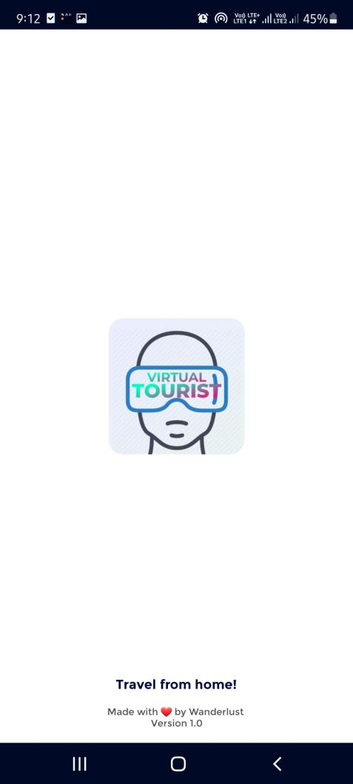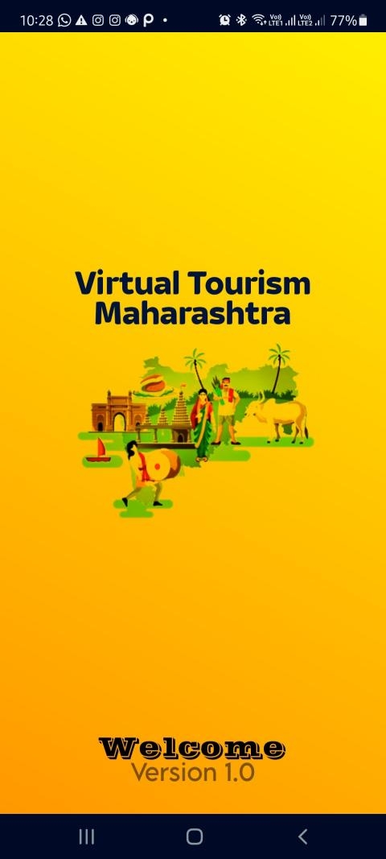. **1.1 Image 1**

Snap. (5.5.1.1) Splash Screen Image-1 2 versions of screen

#### \1.2 image 2

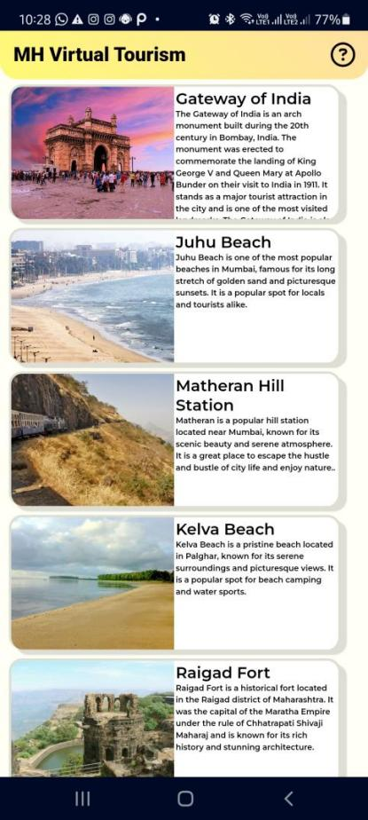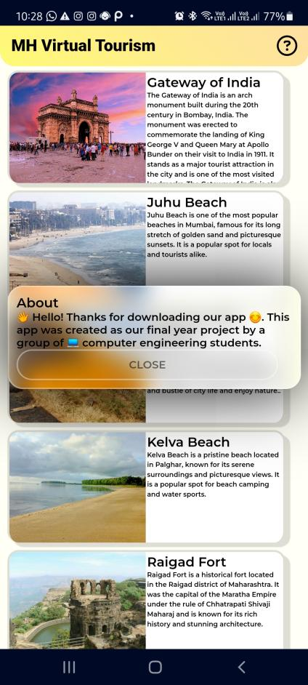

Snap. (5.5.1.2) Home Page Image-2

#### Screenshot_20230403-224717_Maharashtra Virtual TourScreenshot_20230403-223742_Maharashtra Virtual Tour1.3 image 3

Snap. (5.5.1.3) StreetView Page Image-3

CHAPTER SIX

# EXPERIMENTAL STUDY

## 7.1 HYPER TEXT MARKUP LANGUAGE

**7.1.1 What is HTML?**

* HTML stands for Hyper Text Markup Language
* HTML is not a programming language, it is a markup language
* A markup language is a set of markup tags
* HTML uses markup tags to describe web pages
* HTML markup tags are usually called HTML tags
* HTML tags are keywords surrounded by angle brackets like <html>
* HTML tags normally come in pairs like and </ <b> b>
* The first tag in a pair is the start tag, the second tag is the end tag
* Start and end tags are also called opening tags and closing tags.

### 7.1.2 HTML Element

* An HTML element is everything from the start tag to the end tag
* Start tag \_ Element content \_ End tag
* <p>This is a paragraph</p>
* <a href="default.htm" >This is a link</a>

### 7.1.3 HTML Element Syntax

* An HTML element starts with a start tag
* An HTML element ends with an end tag
* The element content is everything between the start and end tag
* Some HTML elements have empty content
* Some HTML elements have a missing end tag>

### 7.1.4 Nested HTML Elements

* Most HTML elements can be nested (can contain other HTML elements).
* Most HTML documents consist of nested HTML elements

### 7.1.5 HTML Headings

HTML headings are defined with the <h1> to <h6> tags.

<h1>This is a heading</h1>

<h2>This is a heading</h2>

<h3>This is a heading</h3>

Note: Use the HTML heading tags for headings only. Don't use headings to make something BIG or bold

### 7.1.6 HTML Paragraphs

HTML paragraphs are defined with the <p> tag.

<p>This is a paragraph</p>

<p>This is another paragraph</p>

### 7.1.7 HTML Links

HTML links are defined with the <a> tag.

<a href="http://www.netmaxtech.com">This is a link</a>

Note: The <a> tag contains an attribute (href) to provide the link address.

### 7.1.8 HTML Attribute

* Attributes provide additional information about HTML elements.
* HTML elements can have attributes.
* Attributes provide additional information about the element.
* Attributes are always specified in the start tag.

## Attribute Syntax

`Attributes always come in name/value pairs like this: name="value"

**Examples** border="1" href="http://www.netmaxtech.com" bgcolor="yellow"

**Attributes Example 1:**

At <table> defines an HTML table. (You will learn more about

HTML tables later)

<table border="1">tributes Example 1:

The border attribute defines a border type for the <table> element.

## LISTS HTML

### 7.1.9 Unordered Lists

An unordered list is a list of items. The list items are marked with bullets (typically small black circles).

An unordered list starts with the <ul> tag. Each list item starts with the <li>tag

### 7.1.10 Ordered Lists

An ordered list is also a list of items. The list items are marked with numbers.

An ordered list starts with the <ol> tag. Each list item starts with the <li> tag.

### 7.1.11 Definition Lists

A definition list is not a list of items. This is a list of terms and explanation of the terms.

A definition list starts with the <dl> tag. Each definition-list term starts with the <dt> tag. Each definition-list definition starts with the <dd> tag

### 7.1.12 Frames

With frames, you can display more than one HTML document in the same browser window, and each frame is independent of the others.

The disadvantages of using frames are:

The web developer must keep track of more HTML documents

It is difficult to print the entire page

### 7.1.13 The Frameset Tag

The <frameset> tag defines how to divide the window into frames.

Each frameset defines a set of rows or columns

The values of the rows/columns indicate the amount of screen area each row/column will occupy

### 7.1.14 The Frame Tag

The<frame> tag defines what HTML document to put into each frame

In the example below we have a frameset with two columns. The first column= 25% of the total width. The second column =75% of the total width. The HTML document "frame\_a.htm" is put into the first column, and the HTML document "frame\_b.htm" is put into the second column.

<frameset cols="25%,75%">

<frame <frame src="frame\_b.htm">me src="frame\_a.htm">

</frameset>

### 7.2 CASCADING STYLE SHEET (CSS)

CSS is a style sheet language used to describe the presentation semantics (that is, the look and formatting) of a document written in a markup language. It’s most common application is to style web pages written in HTML and XHTML, but the language can also be applied to any kind of XML document.CSS is designed primarily to enable the separation of document content (written in HTML or similar markup language) from document presentation, including elements such as the layout, colors, and fonts. This separation can improve content accessibility, provide more flexibility and control in the specification of presentation characteristics, enable multiple pages to share formatting, and reduce complexity and repetition in the structural content (such as by allowing for table less web design). CSS can also allow the same markup page to be presented in different styles for different rendering methods, such as on-screen, in print, by voice (when read out by a speech-based browser or screen reader) and on Braille-based, tactile devices. While the author of a document typically links that document to a CSS stylesheet, readers can use a different style sheet, perhaps one on their own computer, to override the one the author has specified

* CSS stands for Cascading Style Sheets.
* Styles define how to display HTML elements.
* Styles were added to HTML 4.0 to solve a problem.
* External Style Sheets can save a lot of work.
* External Style Sheets are stored in CSS file

**Example for CSS**:

<html>

<head>

<style type = “text/css”>

{Background-color: #b4c4de;}

</style> </head>

**7.2.0 What CSS can do?**

CSS is a style language that defines layout for an entire web site or any HTML document. For example, CSS covers colors, fonts, headings, margins, lines, breaks, height, width, background images, advanced positions and many other things.HTML can be misused to add layout to websites or it can be created trouble for layout. HTML can define layout for any page or website but HTML is not for layout designing. So Cascading Style Sheet offers more options and is more accurate and sophisticated. Because the CSS is exclusive for design layout of website. CSS is supported by all browsers today

#### 7.2.1 Difference between CSS and HTML

CSS is used exclusively for formatting structured content of a single web page or the entire web site. HTML is used to structure content or website. Tim Berners Lee invented the World Wide Web, the language HTML was only used to add structure to text. An author could mark his text by stating "this is a headline" or "this is a paragraph" using HTML tags such as <h1> and <p>. As the Web gained popularity, designers started looking for possibilities to add layout to online documents. To meet this demand, the browser producers (at that time Netscape and Microsoft) invented new HTML tags such as for example <font> which differed from the original HTML tags by defining layout - and not structure. This also led to a situation where original structure tags such as <table> were increasingly being misused to layout pages instead of adding structure to text. Many new layout tags such as <blink> were only supported by one type of browser. Cascading Style Sheet was invented to remedy this situation by providing web designers with sophisticated layout opportunities supported by all browsers

#### 7.2.2 ADVANTAGES OF CSS

1. CSS saves time: When most of us first learn HTML, we get taught to set the font face, size, color, style etc. every time it occurs on a page. This means we find ourselves typing (or copying & pasting) the same thing over and over again. With CSS, you only have to specify these details once for any element.
2. Pages load faster Less code means faster download times.
3. Easy maintenance to change the style of an element, you only have to make an edit in one place.
4. Superior styles to HTML CSS has a much wider array of attributes than HTML.

#### 7.2.3 DISADVANTAGES OF CSS

1. **Browser compatibility**: Browsers have varying levels of compliance with Stylesheets. This means that some Style Sheet features are supported and some aren’t. To confuse things more, some browser manufacturers decide to come up with their own proprietary tags.
2. **Different syntax to HTML**: CSS was developed independently of HTML and uses a different syntax, so a web developer has to learn two sets of formatting syntax instead of one. CSS syntax is also rather clumsy and user-unfriendly.
3. **Requires access to external files**: If you save an HTML file on disk without the associated style sheet then it will lose its formatting when you look at it offline. Similarly, any pages which depend on a web-level sheet will lose their formatting if access to the web-level sheet site is lost. Similarly, all material linked to from access file (images, for instance) must be available for the CSS to work properly.
4. **Can easily be overridden**: Because CSS is an open text-based system there is no security built in, and anyone with read/write access to a website can disrupt the formatting by changing the CSS files or altering the links in the webpages.
5. **Complicates** **templates**: CSS files are particularly troublesome within authoring packages which use templates, like Dreamweaver, since a CSS link that works within the template may not necessarily work when the template is used to create web page.

### 7.3 JAVASCRIPT

**7.3.1 What is JavaScript?**

* JavaScript was designed to add interactivity to HTML pages
* JavaScript is a scripting language
* A scripting language is a lightweight programming language
* JavaScript is usually embedded directly into HTML pages
* JavaScript is an interpreted language (means that scripts execute without preliminary compilation)
* Everyone can use JavaScript without purchasing a license **7.3.2 Are Java and JavaScript the Same?**

NO! Java and JavaScript are two completely different languages in both concept an design! Java (developed by Sun Microsystems) is a powerful and much more complex programming language - in the same category as C and C++ .

**7.3.3 What can a JavaScript Do?**

* JavaScript gives HTML designers a programming tool - HTML authors are normally not programmers, but JavaScript is a scripting language with a very
* simple syntax! Almost anyone can put small "snippets" of code into their HTML pages.
* JavaScript can react to events - A JavaScript can be set to execute when something happens, like when a page has finished loading or when a user clicks on an HTML element
* JavaScript can read and write HTML elements - A JavaScript can read and change the content of an HTML element
* JavaScript can be used to validate data - A JavaScript can be used to validate form data before it is submitted to a server. This saves the server from extra processing
* JavaScript can be used to detect the visitor's browser - A JavaScript can be used to detect the visitor's browser, and - depending on the browser - load another page specifically designed for that browser
* The Real Name is ECMAScript. A JavaScript can read and change the content of an HTML element
* A JavaScript can be used to validate form data before it is submitted to a server. This saves the server from extra processing
* A JavaScript can be used to detect the visitor's browser, and - depending on the browser - load another page specifically designed for that browser

Browser JavaScript's official name is "ECMAScript". The standard is developed and maintained by the ECMA organization’s language was invented by Brendan Each at Netscape (with Navigator2.0), and has appeared in all Netscape and Microsoft browsers since 1996.The development of ECMA-262 started in 1996, and the first edition of was adopted by the ECMA General Assembly in June 1997.The standard was approved as an international ISO (ISO/IEC 16262) standard in 1998.The development of the standard is still in progress.

Java Script

<html>

<body>

<h1> My First Heading </h1>

<p> My first paragraph. </p>

</body>

</html>

The HTML <script> tag is used to insert a JavaScript into an HTML page.

#### 7.3.4 How to Put a JavaScript into an HTML Page

<html>

<body>

<script type=”text/Javascript”> document.write(“ hello World ! “);

</script>

</body>

</ html >

The code above will produce this output on an HTML page:

Hello World!

#### 7.3.5 JavaScript Statements

A JavaScript statement is a command to the browser. The purpose of the command is to tell the browser what to do. This JavaScript statement tells the browser to write "Hello Dolly" to the web page:

document.write("Good Morning");

It is normal to add a semicolon at the end of each executable statement. Most people think this is a good programming practice, and most often you will see this in JavaScript example son the web. The semicolon is optional (according to the JavaScript standard), and the browsers supposed to interpret the end of the line as the end of the statement. Because of this you will often see examples without the semicolon at the end. Note: Using semicolons makes it possible to write multiple statements on one line.

**What is Java**

Java is a high-level, object-oriented programming language that was developed by Sun Microsystems (which was later acquired by Oracle Corporation) in the mid-1990s. It is designed to be platform-independent, meaning that Java code can be written once and run on any platform that has a Java Virtual Machine (JVM) installed, including computers, mobile devices, and servers.

**Use of JAVA in App Development**

Java is widely used in app development, both for building native mobile apps and cross-platform apps. Here are some ways Java is used in app development:

- Android App Develoopment - For Backend part adds Functionality

- Cross Platform App Dev - TO develop appwith native platforms like Flutter and React

- Enterprise App Development

- Game Development

CHAPTER SEVEN

# IMPLEMENTATION DETAILS

## 8.1 INTRODUCTION

This is the good part where I get to tell you how this app works. This app uses two main APIs: Streetview by Google and Mapbox API. The Streetview API loads Streetviews and 360 images using latitude and longitude coordinates that we've hard-coded directly in the HTML as attributes. Mapbox API loads images and maps, acting as a backup API when there's no Streetview available. If the user has a bad network and it's difficult to load the Streetview, Mapbox API will display the map instead.

As for the design, the main home screen, which contains 35 places from 35 districts, is also designed using HTML. To make the app more efficient, we decided to use HTML. That way, we wouldn't have to add 40 images of different places, reducing the app size from 100-200 MBs to less than 10 MBs. Instead, we directly use the image link, which loads the image as a place preview on the home screen. Mapbox API can also be used to load images of places, but it was a little tricky to do, so we opted for the easier way.

**8.2 OVERALL DESCRIPTION:**

### 8.2.1 Description

* You can add as many places as you want directly by adding some links and Coordinates
* The app/website uses 2 APIs Google Streetview and Mapbox
* Most of the app is coded in Web Document with HTML, CSS, JS
* App sizes less than 10mb because we used the efficient way.
* The images are loaded directly from web that way no images take up size in app.

• The Streetview can be loaded using Latitude and Longitude.

### 8.2.2 Web Pages details

* Splash Screen
* Home Page
* Street View
* Map
* About Screen
* Place Description

## 8.3 SYSTEM REQUREMENTS

- Stable Internet

- Atleast 2GB RAM

- Laptop, PC, Mobile devices

-

**8.5.1 What is Application Testing and How Does It Work?**

Application testing is the process of putting an Application through its paces. It aids in the prevention of errors and provides value to the product by ensuring that it meets the needs of the client. The goal of testing is to check that The dependability of software Quality of software Assurance of the System Maximum capacity usage and performance Setting up an Application system is a complicated process that is influenced by a variety of market-specific factors. Testing is now required to preserve the integrity of the Application system.

applications/sites can also be web or mobile applications.

As a result, they are subjected to all of the standard tests.

* Functional Testing
* Usability Testing
* Security Testing
* Performance Testing
* Database Testing • Mobile Application Testing
* A/B testing.

Retail sites, on the other hand, are quite dynamic. There are fresh promotions, new products, new bestsellers, and sales, among other things. This indicates that the site isn't static for long periods of time.

As a result, many people may find it overwhelming.

### 8.5.2 Homepage - Best Image

The Homepage of app/Website is just List of places with their name, Description and Image The Name and Description of places is taken Directly hard coded into code the images on the other hand are loaded directly from web.

### 8.5.3 Perform a search

The option isn’t needed

### 8.5.4 Place Information Page

The place information or Description page is apage that displays place description which is hard coded in code.

**8.5.5 Adding Place**

This option isn’t needed

### 8.5.6 Application/Website Automation Challenges

To be on the cutting edge and offer the desired outcomes to clients, we must focus on the quality and functionality of your Application/website while reducing the timeline as much as feasible.

In general, Automation Testing begins with the selection of the appropriate test automation framework, which has a direct impact on the test automation project's outcome. Test scripts and scenarios for various automated processes must be included in the framework.

We can quickly conduct the tests and acquire appropriate results by generating test reports using the framework. However, choosing the correct tool to automate Testing might be difficult. The success of a app/website is determined by a number of important factors.

CHAPTER EIGHT

## CONCLUSION & RECOMMENDATION

### 9.1.1 CONCLUSION

. In conclusion, the Maharashtra Tourism App can be an excellent tool for tourists who want to explore the state's diverse culture, history, and natural beauty. The app provides users with a wealth of information on various tourist destinations, accommodations, transportation, and local events. It is user-friendly and easy to navigate, making it an ideal choice for both domestic and international travelers.

Moreover, the app's interactive features, such as Streetview, Map navigation, and virtual tours, enhance the user's experience and help them plan their itinerary effectively. The app also offers personalized recommendations based on the user's interests, making it a unique and customized travel guide.

Overall, the Maharashtra Tourism App is a well-designed and informative app that can help tourists explore the state's rich heritage and breathtaking landscapes. It is a must-have for anyone planning to visit Maharashtra and wants to make the most out of their trip.

### 9.1.2 FUTURE SCOPE

There is a scope for further development in our project to a great extent. A number of features can be added to this system in future like providing other home-based services. The feature like adding an option to add their own favourite place or Adding more places with more Views, Images and Maps.

## REFERENCES

### REFERENCES

1. Tutorials Point, “App Development and React For Beginners” Jan. 21, 2023. [Online].

Available: [ReactJS - Introduction (tutorialspoint.com)](https://www.tutorialspoint.com/reactjs/reactjs_introduction.htm) [Accessed Feb. 18, 2023]..

1. GeeksForGeeks, “App Development Introduction for beginners” Jan. 31, 2022. [Online]. Available: [App Development - GeeksforGeeks](https://www.geeksforgeeks.org/nodejs/?msclkid=13bbe134cfa911ec8a288597dd14d9a8) [Accessed Feb. 18, 2023].
2. Google StreetView Documentation , Feb. 21, 2023. [Online]. Available: [What Is](https://www.mongodb.com/what-is-mongodb?msclkid=b9ad9793cfa811ec9cbf2a06f147e876) StreetView API [Accessed Feb. 18, 2023].
3. Java Development, “What is Java ” Jan. 21, 2022. [Online]. Available: Code with Harry Java Tutorial Series[Accessed Feb. 18, 2022].
4. Lama Dev YouTube, “Complete E-commerce

Website” Sep. 2, 2021. [Online].

Available : [(914) React E-Commerce App Design Tutorial | React Shopping Cart UI Design - YouTube](https://www.youtube.com/watch?v=c1xTDSIXit8) [Accessed Feb. 18, 2022].